Venkatesh Thippirishetty Phone: +91 9492582370
Oracle Applications DBA E-Mail: venky0536@gmail.com
Summary

Four+ years of experience as an Oracle Apps DBA at Wissen Infotech Pvt. ltd supporting clients located in North American, APAC, Europe, and Latin American countries on a 24 x 7 basis operating on different time zones simultaneously. Have demonstrated hands on experience in different versions of Oracle E-Business suite. (11.5.10.x and R12.x) which includes RUP and baseline patching, Installations and Upgrades. Strong database Administrative skills and having working experience on oracle RDBMS 9i, 10g, and 11g. Good working experience in various oracle applications versions 11.5.10.2, R12.1 and accurate troubleshooting skills in oracle application front-end login issues.
- Excellent shell scripting, batch programming. Automated several routine DBA tasks and schedule jobs in crontab and other scheduling agent like Appworx
- Proficient in DBA tools like – SQL Developer, OEM11g, 12c Scheduling tools like Appworx.
- Excellent analytical, problem-solving and learning skills and ability to quickly embrace and understand new technologies as well as a keen interest in the emerging technologies.
- Installed and Configured Oracle Enterprise Manager 12c agents.
- Worked on Oracle Applications Cloning and Oracle Database Refreshes.
- Upgraded Oracle Applications Database from 10g to 11g.
- Reduced the timelines of patching using features like Merge Patch, nocomplie options etc.
- Knowledge of Oracle Golden Gate

Employment History

- Wissen InfoTech Pvt Ltd, Hyderabad November 2013 - Till date

Educational Summary

- Bachelor of Technology (CSE) from JNT University.

Skill Set

Operating Systems | Linux, Red Hat, IBM AIX, Windows
Databases | ORACLE11g, 10g, 9i
Applications | Oracle Applications R12 ,11.5.10.2 and 11.5.9
Tools & Utilities | Appworx, STAT, WinSCP , MS Office, SQL Developer, VNC viewer
Ticketing Tools | Service-Now (GE-TSG), SAP C4C,Salesforce, Altiris ticket ,Jira, iTop

Responsibilities (as Oracle Applications DBA across all projects):
- Performing cloning from Production to Test/Dev/Project environments.
- Troubleshooting Web, Form, Concurrent Related issues.
- Migrating Code packs to Production instance through STAT tool
- Deployed datafixes to correct the data mismatch issues in Production instances
- Installed Oracle Applications to new languages and applying country specific localizations
- Integrated third party applications into E-Business Suite.
- Performed RUP patching and upgraded Oracle Apps databases.
- Resolved Oracle Applications issues with Forms, Apache, CM, and Workflow.
- Applied patches including thorough Patch analysis.
- Resolved configuration issues raised by development teams.
- Used Oracle Application AD Utilities for maintaining database and application like adpatch, adadmin, adctrl, admrgpch etc.
- Performed Application user password changing activities using FNDCPASS utility.
- Applied Quarterly release of Oracle Critical Patch Updates to Oracle Application Databases.
- Worked on user account management - creating users, disabling users and responsibility management.
- Managing concurrent managers -ensure system is running smooth by monitoring throughput and watching for long running requests.
- Performed sysadmin tasks as per the requirement.
- Copying new forms, reports, custom code to production environment from Development.
- Worked on changing passwords of apps, sys, system and specialized users every quarter in TEST, DEV and PROD.
- Documented tasks in coordination with onsite team.
- Decommissioned Application instances.
- Installed new products as per business requirement.
- Applied monthly payroll patches and latest vertex payroll update for HRMS Products.
- Reduced the timelines of patching using features like Merge Patch, nocomplie options etc.
- Exposure to Tune the Database, User management, Table Space management.
- Re-org of schemas and rebuilding related indexes to improve the performance.
- Scheduled BEN schema purge program to improve the performance.
- Performing health check on production & test environments.
- Schema refresh based on client requirement.
- Support/Maintain/Troubleshoot Apps various environments.
- Cloning using Rapid clone, Autoconfig and adclone utility.
- Responsible for maintaining the Oracle Apps Instance, setting and maintaining the application on 24x7 kind of availability.
- Maintaining system security, defining of roles, profiles etc.
- Scheduling daily RMAN Incremental hot backups and weekly Cold backups.
- Performing health check on production & test environments.

Project Profile 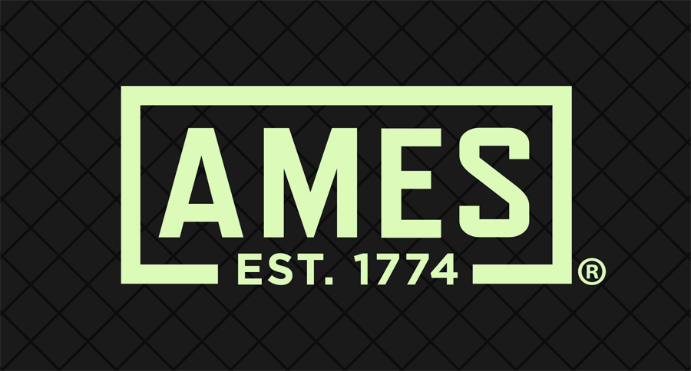

Project Name: Remote Database administration
Client | AMES – Remote DBA support
Role | Oracle Application DBA
Organization | Wissen Infotech pvt. Ltd, S.P.Road , Secundrabad
Duration | Oct-2017 to Till date

Project Description

Ames True Temper is a multinational corporation headquartered in Camp Hill, Pennsylvania, USA. Ames True Temper specializes in the manufacture of non-powered lawn and garden products,With a history of high-quality tool manufacturing dating as far back as 1808, Ames True Temper has long been a trusted name throughout the horticultural industry. At A.M. Leonard, we offer a huge selection of Ames True Temper tools ranging from snow shovels to hatchets. As to support the business, client has implemented databases on Oracle 9i/10g.
Environment: Linux and Oracle 10g, Oracle Applications 11i, Oracle Enterprise Manager, Microsoft Windows Server 2008.
Project Profile 

Project Name: Remote Database administration
Client | Genband – Remote DBA support.
Role | Oracle Application DBA
Organization | Wissen Infotech pvt. Ltd, S.P.Road , Secundrabad
Duration | Nov 2013 – Till date

Project Description

GENBAND US LLC was a privately held company that makes IP-based real time communications software products for fixed wireline, mobile, and cable service providers as well as large enterprises. It works with over 80 of the global top 100 service providers and has more than 800 customers in 80 countries. As to support business, client has implemented databases on Oracle 11g.
Environment: Linux and Oracle 11g, Oracle Applications R12.1.3, Oracle Enterprise Manager, Oracle Application Server 11g.

Project Profile 

Project Name: Remote Database administration
Client | ERA – Remote DBA support.
Role | Oracle Application DBA
Organization | Wissen Infotech pvt. Ltd, S.P.Road , Secundrabad
Duration | Jan-2015 to Till Date

Project Description

With 70 years of experience, Era is one of the largest helicopter operators in the world and the longest serving helicopter transport provider in the U.S .
Environment: Linux and Oracle 11g, Oracle Applications R12.1.3, Oracle Enterprise Manager, Oracle Application Server 11g..
Project Profile 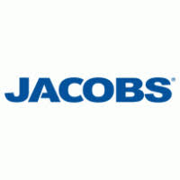
Project Name: Remote Database administration
Client | JACOBS – Remote DBA support.
Role | Oracle Application DBA
Organization | Wissen Infotech pvt. Ltd, S.P.Road , Secundrabad
Duration | Jan 2014 – Jan 2017

Project Description
Jacobs main focus on building long-term client relationships and provides technical, professional and construction services, including all aspects of architecture, engineering and construction, operations and maintenance, as well as scientific and specialty consulting. Wissen InfoTech provides offshore DBA support to Jacobs, Inc. Wissen manages nearly 100 databases in different platforms remotely which includes core and APPS databases.
Environment: IBM AIX, Linux and Oracle 10g/11g, Oracle Applications 11i,R12.1.3, Oracle Enterprise Manager, Oracle Application Server 11g, Microsoft Windows Server 2008/2012/2014.
Declaration
I hereby declare that all the information furnished above is true to the best of my knowledge.

Venkatesh Thippirishetty
Place: Hyderabad Date:

